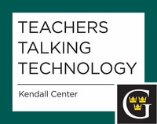

All Teachers Talking Technology sessions are held from 11:30 a.m. to 12:20 p.m. or 12:30 to 1:20 p.m. Free lunch at the Three Crowns Buffet, then meet in the Heritage Room.

2014-15
Tuesday, September 16, 2014
All Things Moodle

