2013-2014
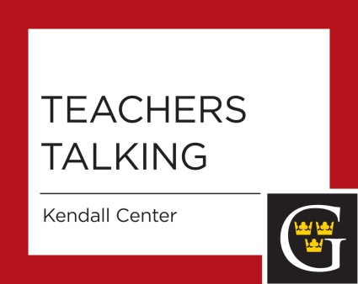
Thursday, September 12, 2013
Writing Effective Tenure/Promotion/3rd Year Review Letters -- One singular element of the tenure/promotion/3rd year review process at Gustavus is the invitation (and sometimes requirement) that faculty write letters for their colleagues undergoing review. Beyond the request that "letters should address the candidate's qualifications for the criteria", we receive little guidance about how to write letters that the Personnel Committee and 3rd Year Review Committee find useful in the review process. All of that changes now! Join Casey Elledge (current Personnel Committee chair), Paul Saulnier (past chair), and Marie Walker (past chair) for a conversation about the characteristics of effective review letters, what works, what to avoid, and lots more.
Thursday, October 10, 2013
What?! Our Students Drink in High Risk Ways? While drinking in college may seem a rite of passage and just harmless fun, for a number of our students it is not. Faculty have some of the most regular and sustained contact with students. This Teachers Talking session on Thursday, October 10 will be facilitated by Peg O'Connor and Tricia Frerick, and focuses on potential warning signs, offers some suggestions for engaging students, and directs faculty to the various resources available on campus.
Thursday, November 7, 2013
Teaching Texts and Subjects that Trigger Trauma for Students (Co-sponsored with Provost's Office)
Staff from the Counseling Office will explore the triggering of trauma responses in the classroom and will identify strategies to support students experiencing such responses. Discussion will focus on how faculty can best provide this support while continuing to address course content.
Tuesday, December 10, 2013 (with New Faculty Orientation Session)
Interdisciplinary Programs - Interdisciplinarity is an integrative and cross-disciplinary approach to learn about the world. Students at Gustavus Adolphus have multiple opportunities to engage in interdisciplinary educational experiences including majors, minors and study abroad experiences. Come learn about some of these programs and meet/reconnect with colleagues involved in them.
Thursday, February 27, 2014
Global warming will define our students’ futures: it will change where people grow food, find fresh water, and will make millions homeless by the end of this century. Do you want to address climate change's cultural, political, and economic features in your courses, but need a concise guide to current climate science? If so, come to this special Teachers Talking, where we’ll give you some quick and easy climate information and will exhibit a sample module you could use in your classes to get the conversation rolling. Our working group will also develop additional modules to meet /your/ specific needs.
Thursday, March 18, 2014
Sexual Harassment and Bullying in Labs, Studios and Other Minimally Supervised Learning Environments Data show that higher levels of harassment and bullying occur in learning environments such as labs and studios than in more traditionally supervised classrooms. Dean O'Loughlin will provide an overview and explanation of these data and faculty will be invited to share their strategies to protect students from harassment in varied learning environments. We will discuss how to make these spaces safer for students while still supporting the independent learning crucial to these learning environments. (Co-sponsored with Provost's Office)
Wednesday, April 23, 2014
"What Do I Do When...? Medical Emergencies in the Classroom." Seizures, loss of consciousness, diabetic reactions, and respiratory difficulties are just a few of the medical emergencies that occur in college classrooms. Yet many faculty report not knowing what to do for a student experiencing these symptoms. Of course, call Campus Safety. But what about the time before they arrive? Join Heather Dale, Director of Health Service, Nissa Fell and Jessica Braun, nurse practitioners, to learn what to do when such an event occurs in your classroom.
Wednesday, May 7, 2014
Teachers Talking on writing effective letters of recommendation.

