2013-2014
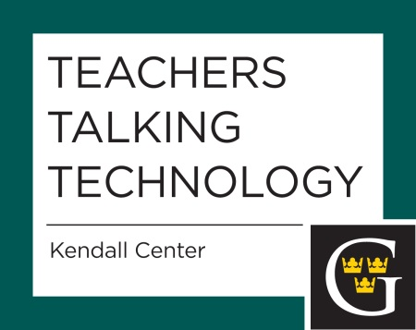

Tuesday, September 17, 2013
Join us for a blast from the past as the grade school show and tell makes a higher education comeback. Participants will take turns sharing how they are using technology for teaching or scholarship in an idea exchange luncheon.
Tuesday, October 15, 2013
Do you feel too busy? Is there always more to get done? This is a special panel discussion on the culture of productivity and technology's role. The session will feature panelists Dwight Stoll, Kathy Lund Dean, Sean Cobb, and Barbara Fister.
Tuesday, November 12, 2013
Want to learn how to embed a YouTube video in your course? Or how do you download all those papers at one time so you can read and grade them? Maybe you've always thought you wanted to add a Forum to your course, but wasn't sure how to proceed. We'll share just some of these things, as well as some tips and tricks! And we'll answer any questions you might have, as well! So, join us!
Tuesday, February 25, 2014
Topic: Extending the Discussion: Using Goodreads and Blogging in the College Classroom. In this session, Katrina Imison-Mazy and Valerie Walker will share their experiences using social media to enhance classroom discussion and promote active participation in on-line communities. They will share their rationale and what they've learned about designing assignments, assessment, teaching the technology, and developing authentic and rich discussion communities.
Tuesday, March 13, 2014
A World Café styled Teachers Talking Technology about how the emerging technologies described in the 2014 Horizon Report may impact learning, teaching, and creative inquiry at Gustavus. If you have a few minutes before the session, glance at the Horizon Report preview (http://www.nmc.org/pdf/2014-horizon-he-preview.pdf), but printed copies will also be available at the session. Note: if interested, you can also read the complete report at http://www.nmc.org/pdf/2014-nmc-horizon-report-he-EN.pdf

Tuesday, April 15, 2014
Join Jessie Petricka (Physics) and Kyle Chambers (Psychological Science) on Tuesday, April 15th for a Teachers Talking Technology focusing on the use of student response systems (e.g., Turning Technologies) to increase student engagement and improve learning outcomes.
Tuesday, May 6, 2014
The use of sophisticated software in higher education is changing rapidly as software companies and users of their products shift to a cloud-based computing paradigm. Recently, Adobe Systems Inc., maker of such programs as Photoshop, Acrobat, InDesign, and Illustrator, has radically changed their licensing scheme in ways that make continued use of these products cost prohibitive for some college campuses. In this Teachers Talking Technology session we invite faculty to come together to discuss this issue. Dwight Stoll (Chemistry; Chair, Academic Technology Committee) will facilitate a discussion around three questions: 1) in what ways does the change in licensing at Adobe (or other vendors) affect your teaching and scholarship?; 2) do you know of open-source alternatives to the Adobe product line (or others) that other faculty at Gustavus should be aware of?; 3) what is your philosophical stance on the question of whether or not adequate preparation of our students must involve hands-on experience with these mainstream software products that are becoming very expensive (e.g., Photoshop)? We hope that this discussion will not only lead to a broader awareness of these changes across campus, but also inform the way the College will move forward in the near future as GTS and ATC discuss how to deal with the increasing cost of software on campus.

