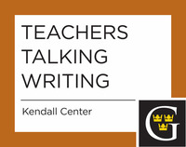

All Teachers Talking Writing sessions are held from 11:30 a.m. to 12:20 p.m. or 12:30 to 1:20 p.m. Free lunch at the Three Crowns Buffet, then meet in St. Peter Room.

2014-2015
Wednesday, October 29, 2014 (PDR)
Working with Multilingual Writers. Increasing numbers of multilingual students are entering Gustavus. This session will discuss their differing profiles and needs, address “the politics of grammar and usage” in the context of “Global Englishes,” and recommend ways to help multilingual students articulate and address their own goals as writers.
Tuesday, April 14, 2015 (Heritage Room)
Teaching Content or Teaching Writing? Do they complement or conflict? This session will focus on successful, quick classroom strategies for promoting "content retention" while building skills in written communication.

