2013-2014
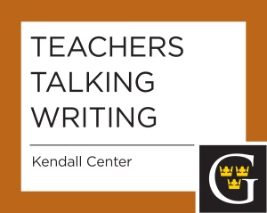

Wednesday, October 16, 2013
Comments that Count: Responding to Student Writing. This session will be a conversation about how to improve student writing without drowning in a sea red ink.

Wednesday, April 16, 2014
Join us for Teachers Talking Writing on Wednesday, February 26. The topic is "Writing to Learn across the disciplines:" Faculty who attended January's GACWAC workshop ("Reinvigorating Writing Across the Curriculum") will describe new approaches to using writing as a tool to generate student enthusiasm for learning. Faculty from all divisions, from the Arts to Social Sciences, will be represented.

