Innovative Teaching Award Recipients
2021-2022

Colleen Stockman
Assistant Professor in Art and Art History
Innovative Teaching Award - Innovative Assignment
Title: Repatriating the Parthenon Marbles: An Art History Midterm

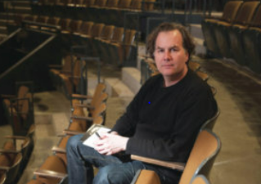
Henry MacCarthy
Associate Professor in Theatre and Dance
Innovative Teaching Award - Innovation at the Course or Curricular Level
Course: T//D 110: Performance Practicum, T/D 119: Assistant Directing and TD 270: Intermediate Creative Research

