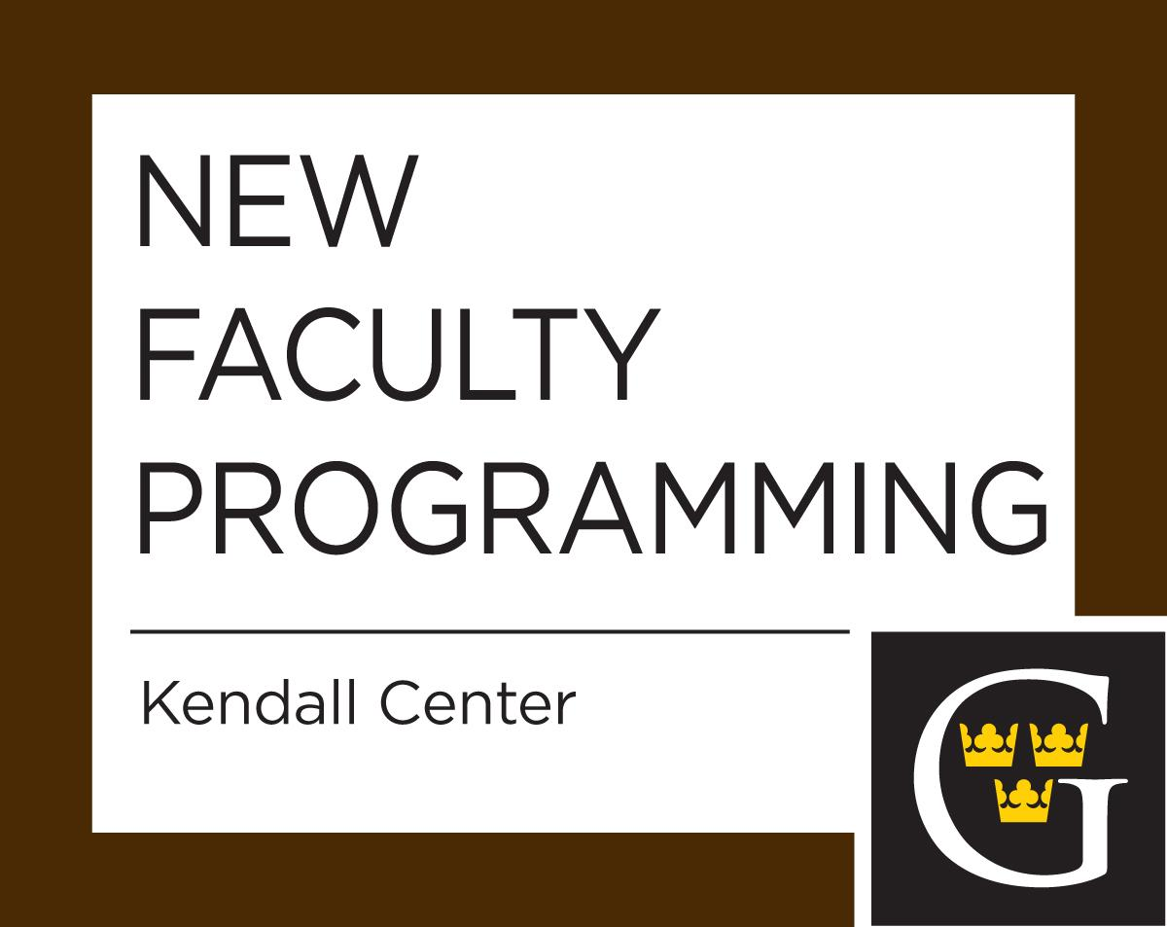

2020-2021 Monthly Orientation Sessions
All Sessions are Thursdays from 12:30 - 1:20 p.m.
Free lunch at the Buffet and then meet in the
Saint Peter Room (unless otherwise noted)

All new faculty are strongly encouraged to attend orientation sessions during the year. Department chairs are asked not to schedule your classes at this time. The sessions are an opportunity to share information about issues important to new faculty. Each session focuses on a topic with one or more discussion facilitators. Some sessions are only for non-tenure track (NTT) while others are relevant for tenure track only (TT only). If not denoted, all new faculty members are welcome.

September 17, 2020
Checking‐in session
An open‐ended opportunity for new faculty to get to know each other, share their experiences in the first week, and have questions answered in a supportive environment (e.g. J-term proposals are due the September 14th). What are your intentions for the semester and how might your goals be reached?
September 24, 2020
Grading: Policies and Rubrics
How might we grade assignments strategically? We can save time while giving students valuable feedback. We will also discuss the nuts and bolts of grading policies in general. A variety of assignment types are discussed.
October 1, 2020 NTT only
Making the Most of Term Appointments – Workshop CV and Interviews
You just started, but may be in the process of applying for a tenure track job. How do you position yourself as a top candidate? Bring an example of your CV and we will workshop it. What do Departments look for when hiring? How do you prepare and deliver for an interview?

October 22, 2020
Course Evaluations
A discussion of effective methods for evaluating your courses and getting information that can be used to improve teaching and learning. We focus on end of the semester summative as well as mid-semester formative evaluations.
October 29, 2020
Evaluations by Colleagues
In collaboration with the Provost’s Office, a discussion about the procedure and potential approaches associated with evaluations. What might you share with your evaluator prior to the class period, how to inform your class, the criteria and areas that Chairs are asked to evaluate, post-evaluation feedback.
November 12, 2020
On-campus Grant Opportunities
Learn about internal and external grant opportunities: scope of each grant, timing, budgets, and how to apply.
January 14, 2021
Religious diversity and the College's Lutheran affiliation
Learn how Gustavus’ Lutheran heritage and affiliation impacts who we are today, our mission, our commitment to religious diversity and inclusion, and our vision for the future.

February 11, 2021
Checking In and Setting Intentions
Share your reflections or questions over lunch about your experiences in the fall semester and/or during January. What was more difficult or odd than anticipated, or what was gratifying? What strategies or intentions do you have for the spring semester?

February 18, 2021 1st and 2nd year TT only
Review processes at Gustavus
This discussion provides an overview of the first, third year and tenure review procedures at Gustavus, and confidentially addresses any questions you have about them.
February 25, 2021
Honor code at Gustavus
This discussion provides new faculty with a shared understanding and application of the honor code at Gustavus. We will discuss faculty responsibilities, including providing definitions of what constitutes authorized aid for coursework and specifying the possible course penalties for violations of the Honor Code. An overview of the workings of the Honor Board system will be provided.

March 11, 2021
Best Practices in Advising
This discussion provides a foundation for best practices in advising. You will be exposed to a variety of resources that can help you develop into an effective academic advisor in the context of the liberal arts. First-year Gustavus tenure track faculty will also learn about the built-in advisor development opportunities that are coming up in their second year.
March 18, 2021
Committee Roles
This discussion focuses on one’s role in service capacities, specifically as a committee member. It also will highlight good committee choices for junior faculty, what might be expected of you on these committees, and how you might constructively contribute to committees in general.

April 15, 2021
The Power of the Liberal Arts
This discussion will broadly cover: the role of the liberal arts in our students’ educational experience; how faculty can enhance our students’ understanding of what the liberal arts means, and; how students can leverage their degree from a liberal arts college. We also can discuss how teaching or scholarship could be re-conceptualized when you are working in a liberal arts context, and how the liberal arts can cultivate aspects of our broader lives.

April 21, 2021
New Faculty Social (including Mentors and all new faculty from past 2 years)
4:30 to 6 p.m. in the St. Peter Room

May 6, 2021
Year in review and wrapping up the year
In this final session of the year, we can discuss outstanding questions or concerns, and we will celebrate your accomplishments. Faculty feedback about the orientation program also will be gathered.

