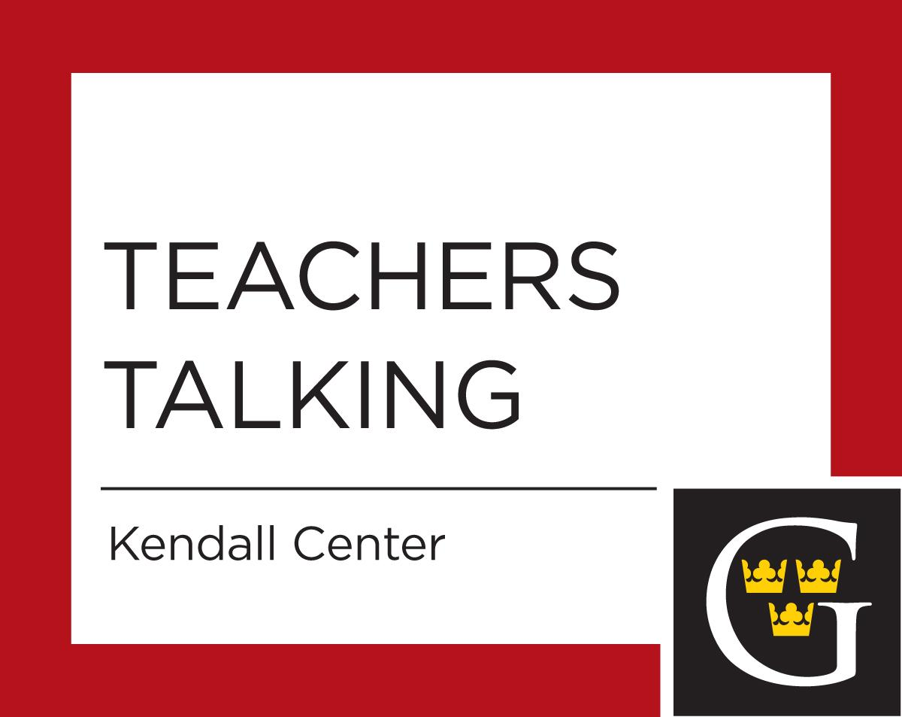
2019 – 2020 Teachers Talking
11:30 to 12:20 p.m. and 12:30 p.m. to 1:20 p.m.
Three Crowns Buffet, free lunch then meet in St Peter/Heritage Room

Thursday, September 12, 2019
J Term
Join Hayley Russell and Scott Bur to discuss the nuts and bolts of submitting a proposal for a new J-Term (IEX) course. We will review the course proposal form and answer questions about the application process. Whether it's your first or twentieth J-Term course, all are welcome.
Presenters: Hayley Russell
Wednesday, September 18, 2019
Teaching Student Athletes
In "Teaching Student Athletes" we will discuss how students balance academics and athletics, and the role of intercollegiate athletics at Gustavus. We will also share attendance policies and discuss issues regarding missed class time for athletes.
Presenters: Kari Eckheart, Jeff Owen, Jared Phillips
Wednesday, October 16, 2019
Understanding the College's Religion Requirement
What is the college's graduation requirement in Biblical and Theological Studies? What are the different ways in which it is taught at Gustavus? What might future versions of these courses look like in the Challenge Curriculum? Join faculty who have taught this course for a time of sharing questions, stories, ideas.
Presenters: Casey Elledge, Sarah Ruble, Blake Couey, Mary Gaebler, Fuad Naeem
Wednesday, October 23, 2019
Crash Course in Backwards Design
Unsure where to start thinking about designing a new course or revising an old one? Trying to figure out how to incorporate multiple student learning outcomes into a course? Overwhelmed by all the content you need to cover? This crash course will introduce you to backward design, a process that will help you align your course goals, assignments, and activities. Come for lunch, good conversation, and some helpful worksheets
Presenter: Sara Ruble
Wednesday, November 6, 2019
Who are our Multilingual Gusties?
Faculty and staff are invited to come learn about who counts as "multilingual," how many MLL students we have on campus, and see stats on the students' linguistic backgrounds. Multilingual students will share their perspectives on campus and academic life in their own words.
Presenter: Carly Overfelt

Tuesday, December 3, 2019
MAYDAY 2020 - Highlighting Student Activism
Presenter: Glenn Kranking
Monday, January 13, 2020
J-Term Check In!
Join your fellow J-Term instructors to discuss how J-Term is going! This Teachers Talking will focus on problem-solving challenges and celebrating successes in J-Term and connecting with others who are teaching J-Term now, have in the past, or might in the future. All are welcome!
Presenter: Hayley Russell

Wednesday, February 20, 2020
Nobel Conference 2020
The Nobel Conference 2020 focuses on recent advances in cancer treatment and how to make these treatments more accessible to all. Come learn more about the Nobel Conference 2020: Cancer in the Age of Biotechnology with conference co-chairs Laura Burrack (Biology) and Dwight Stoll (Chemistry). We will introduce the range of topics covered by our confirmed speakers and discuss ways to incorporate the conference into classes both this spring and next fall.
Presenters: Laura Burrack and Dwight Stoll

Tuesday, February 25, 2020
how to better visualize the responses on the SRIs
The standard method of viewing the results from the Student Evaluation on Instruction can be difficult to summarize and even more difficult to understand. I wrote a web application that reads in the results from the SRI and generates an easy to read report. Come and learn how to use the web application. Bring your laptop as there will be time for you to generate your own SRI report.
Presenter: Aaron Nienow

Thursday, March 5, 2020
Helping Students with the Research Process
In this presentation, Gustavus librarians will facilitate conversations about patterns we observe when students are conducting research. The session will focus especially on how students work with secondary sources, both scholarly and non-scholarly. We will provide insights and tips for how to help students work better with sources. We also look forward to hearing from attendees about their methods for teaching students about the research process.
Presenter: Library faculty
Wednesday, March 18, 2020
Connecting Career Readiness to the Liberal Arts Classroom
Join the Center for Career Development as we work to strengthen our partnerships across campus. Career will briefly touch on a few examples of how academics and career discernment have partnered to support student growth, exploration and career readiness. Together, we are eager to learn from each other, share best practices and hear how we can create new opportunities for how best we can support your efforts in and outside the classroom.
Presenters: Career Development - Andrew Coston, Jill VanOsdol, Jess Franta:

Workshops: Designing Courses Workshop
October 2, 2019 and January 16, 2020

