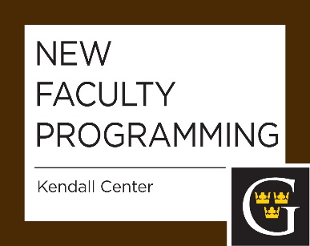
September 8, 2016
Checking‐in & J-Term proposals session – an open‐ended opportunity for new faculty to get to know each other, share their experiences in the first week, and have questions answered in a supportive environment (e.g. J-term proposals are due the next day). What are your intentions for the semester and how might your goals be reached?
September 22, 2016
Grading rubrics and policies – how might we grade assignments strategically? We can save time while giving students valuable feedback. We will also discuss the nuts and bolts of grading policies in general. A variety of assignment types are discussed.
October 6, 2016 (NTT only)
Making the Most of Term Appointments – Workshop CV and Interviews: you just started, but may be in the process of applying for a tenure track job. How do you position yourself as a top candidate? Bring an example of your CV and we will workshop it. What do (Gustavus) Departments look for when hiring? How do you prepare and deliver for an interview?
October 13, 2016
Course Evaluations by Students- a discussion of effective methods for evaluating your courses and getting information that can be used to improve teaching and learning. We focus on end of the semester summative as well as mid-semester formative evaluations.
October 27, 2016
Being Evaluated by Colleagues (with Chairs or Departmental Evaluators). In collaboration with the Provost’s Office– a discussion about the procedure and potential approaches associated with evaluations. What might you share with your evaluator prior to the class period, how to inform your class, the criteria and areas that Chairs are asked to evaluate, post-evaluation feedback.
November 4, 2016
Get a Life Ph.D. Workshop
November 17, 2016
On- Campuis Grant Opportunities

February 9, 2017
Checking In and Setting Intentions
Share reflections on experiences in fall and over January. What goals were met? What were more difficult than anticipated and what are your strategies for the spring semester?
February 16, 2017 (TT only)
Review processes at Gustavus - an overview of the first, third year and tenure review procedures at Gustavus.
March 2, 2017 (open to all TT only)
Committee Roles: shared governance and service- A discussion about one’s roles on committees. A brief discussion of good committees for junior faculty committee do and what might be expected of you?
March 16, 2017 (open to all TT only)
Best Practices in Advising in a liberal arts context - how might you be an effective academic advisor in the context of the liberal arts? Discuss how to get to know students, help tehm develop a four year plan, gain experiences, build skills and intellectual flexibility, and accurately reflect on their strengths.
April 13, 2017
Liberal arts and our Lutheran tradition - Introducing the mission of Gustavus and our unique place in higher education.
April 19, 2017
Mentor - Mentee Social, 4:30 to 6 p.m.
May 11, 2017
Year in review and wrapping up the year - the final session of the year where outstanding questions are answered and faculty feedback about the orientation program is gathered.

