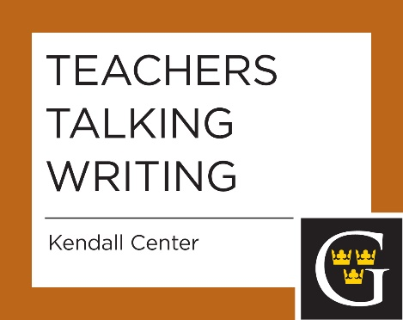

Wednesday, October 5, 2016
Students talking writing. Would you like feedback on writing assignments before you have to grade the results? Would you like a student's-eye evaluation of what works, and what doesn't, in typical assignments? Peer tutors from the Writing Center are the guest instructors for this session. Bring copies of assignments to lunch, or, better yet, send them in advance to Deborah Goodwin (dgoodwin@gac.edu) who will distribute them to tutors.
Wednesday, November 30, 2016
Mentoring multilingual students for success. Meet Multilingual Learner tutor René Wegner (Academic Support Center). Learn from him and other faculty about “Best Practices” to use to support our growing multilingual student population.

