Interested in Working with Patients in a Variety of Healthcare Settings?

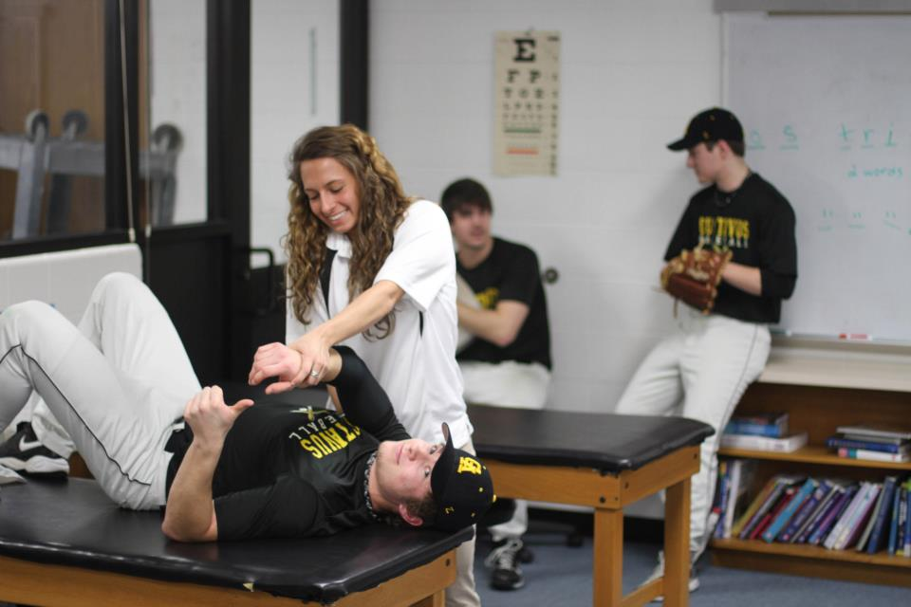
Interested in Treatment, Rehabilitation, and Prevention of Injuries?

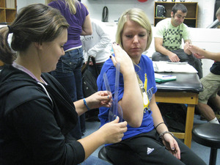
Think about Athletic Training!

First Year Informational Meeting
Lund Center Room 207
November 4th 7:30pm
Questions? Contact Mary Joos mjoos@gustavus.edu

