Functional Magnetic Resonance Imaging  A Look at Your Brain at Work and Play! | 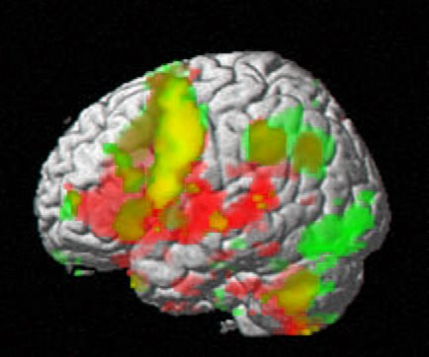

Document Overview:
Explanatory article to read, containing links to follow (internet access preferred)
Discussion Questions (student questions and teacher guide)
Appendix with additional resources

Minnesota State Science Standards:
9.1.3.3.3 Describe how scientific investigations and engineering processes require multi-disciplinary contributions and efforts
9.1.3.4.1 Describe how technological problems and advances often create a demand for new scientific knowledge, improved mathematics and new technologies
9.1.3.4.3 Select and use appropriate numeric, symbolic, pictorial, or graphical representation to communicate scientific ideas, procedures and experimental results
9.1.3.4.6 Analyze the strengths and limitations of physical, conceptual, mathematical and computer models used by scientists and engineers.
9P .1.3.3.1 Describe changes in society that have resulted from significant discoveries and advances in technology in physics.

Objective:
Upon completion of this article, students will be able to:
- describe the basic function of an MRI scanner.
- describe the differences between MRI and fMRI scanning.
- describe potential uses of fMRI imaging

Type of Activity:
Research reading, informative article

Duration
Out of class reading with one or two class periods for discusion; or use as background for other discussions.

Connection to Nobel speakers
John Donoghue, Henry Merritt Wriston Professor, Department of Neuroscience, and Director, Institute for Brain Science, Brown University, Providence, R.I.
  - For more than 20 years John Donoghue has conducted research on brain-computer interfaces, and his laboratory is internationally recognized as a leader in this field. One of the most significant breakthroughs in the field of neural interface systems occurred when Donoghue’s group restored the ability of a quadriplegic patient to operate computer cursors and robotic arms by imagining the movement.

Paul W. Glimcher, Professor of Neural Science, Economics, and Psychology, Center for Neural Science, and Director, Center for Neuroeconomics, New York University
  - Working with Professor David Sparks at the University of Pennsylvania in the early ’90s researching the brainstem and those nuclei that control eye rotations, Paul Consequently, his lab has focused on the identification and characterization of signals that intervene between the neural processes that engage in sensory decoding and those that engage in movement generations. These are the signals that must, in principle, underlie decision-making. Glimcher and his lab study these processes using tools drawn from the fields of neuroscience, economics, and psychology, with methodologies ranging from single-neuron electrophysiology to game theory.

Helen Mayberg, Professor of Psychiatry and Neurology and Dorothy Fuqua Chair of Psychiatric Neuroimaging and Therapeutics, Departments of Psychiatry and Behavioral Sciences and Neurology, Emory University School of Medicine, and Center for Behavioral Neuroscience, Atlanta, Ga.
  - Dr. Helen Mayberg’s research focuses on neural systems mediating mood and emotions in health and disease, with a primary emphasis on major depression and its recovery. Her studies have built a foundation for the refinement and continued testing of Deep Brain Stimulation (DBS) for treatment-resistant depression.

Comments for Teachers:
This document is written as a tutorial to understanding MRI and fMRI imaging. It could be used in a small group for students to read and discuss or for individual reading. Several links exist throughout the article that will enhance the topic. Groups of students are encouraged to discuss and explore the discussion questions to allow collaboration to further clarify the ideas.

fMRI Explained
What types of imaging do people experience? Likely many people have experienced an X-ray, an ultrasound, a CT scan (computed axial tomography), and maybe an MRI (magnetic resonance imaging). Often infants are imaged with ultrasound before they are born. Athletes may have injuries where X-ray and/or MRI imaging are used for diagnosis. Many types of imaging techniques have been developed to allow visualization of the human body for various purposes. This article will provide a brief outline to MRI and fMRI scans.

Most images used are static images of different components of our bodies. This means that the images are taken at a particular time and show the conditions at the moment the image is taken. Traditional X-ray images are this type. These images can distinguish bone from tissue due to a difference in density. Ultrasound imaging takes advantage of varying acoustical properties of different types of tissue to create images at tissue boundaries.
Each type of imaging has strengths in visualizing particular body structures. To investigate the structure of the brain, static images can be helpful. CT scans have been used for many years for this purpose. More recently, MRI is a common imaging tool. But to identify the operation of the brain, we need a scan that can observe changes in the brain over time and not only create a static image. Thus the functional MRI (fMRI) approach.

Magnetic Resonance Imaging (MRI) has been highly developed in the past ten to fifteen years. As many likely know, it has become one of the most common types of techniques for creating detailed internal images of humans. But how does and MRI scanner create an image?

MRI scanners take advantage of the protons in the hydrogen atoms spread in water throughout the body. These atoms naturally spin, and as a result each atom acts like a tiny magnet whose poles are related to the orientation of the spin. The magnetic field points one way for one direction of spin and the opposite way for the opposite spin.
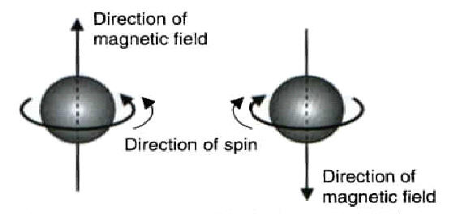

The MRI scanner has a very strong permanent magnet. When a person is placed into the scanner, this large magnetic field causes these spinning hydrogen atoms in the person to line up with the magnetic field of the scanner. In a human, about half of the protons spin one way and the other half spin the other way, causing the net magnetic field of the atoms to be nearly zero. So the atoms in the person line up with the magnetic field of the scanner.
But a small percentage of atoms spins are not cancelled out...resulting in a small amount of net magnetic field left from the atoms. The scanner sends radio signals into the area of interest with a set of antennas (coils of wire) in the scanner. This electromagnetic energy causes these unpaired spinning atoms to change their rotation while the radio signal is applied. When the radio signal is turned off, the atoms rotate back to line up with the original magnetic field of the scanner. As the radio signal is turned on and off, the atoms begin to vibrate in sync with this oscillation. During each vibration, each atom gives off a bit of energy in the process of flipping back to its relaxed state.

Each type of body tissue has a particular rate at which it can vibrate, called its resonant frequency. The hydrogen atoms are made to resonate by the radio signal...hence the name Magnetic Resonance Imaging. The energy that is reemmited by the atoms (in the form of radio waves) is detected by a set of antennas and allows the scanner to map where these atoms are located.

This diagram from HowStuffWorks.com provides a nice illustration of the atoms involved in creating the desired image:

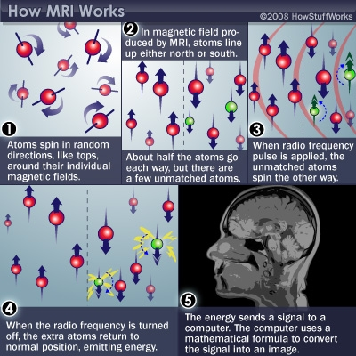

Here is an extensive article that explains more details about how a standard MRI scanner functions: http://www.howstuffworks.com/mri.htm

To direct the scanning to occur at the desired area, a secondary set of electromagnets are used. These can change the shape of the magnetic field and direct the radio signals where they are desired. During the scan, this imaging process is repeated over and over to create an image of a slice of tissue.

While in an MRI scanner, people often experience lots of uncomfortable noise. The coils of wire making the secondary magnetic field to direct the energy interact with the main, permanent magnet in the scanner. As this magnetic field switches back and forth, it is attracted to and repelled by the other field. This causes the loud ‘banging’ sounds that are familiar to people that have been in MRI scanners. Imaging holding two magnets near each other and then letting them go. They may quickly move together or apart. Each time the radio pulse is made, the secondary electromagnets are pushed or pulled on by the primary magnetic field and they bang into each other.

So an MRI scanner can create a very detailed image of the internal structures of the body. But this is still a static image. To analyze brain function, an image is needed that can show how chemicals are changing in the brain over short amounts of time. A functional MRI scan is essentially an image that shows where oxygen is used in the brain.

Humans need oxygen! It is carried to the brain by the hemoglobin in the bloodstream to allow the brain to function. Functional Magnetic Resonance Imaging, known as fMRI, is being developed to allow a look at the brain’s usage of oxygen. An MRI collects information from magnetic changes that occur as protons in the body interact with radio signals transmitted by the scanner and re-emitted by the brain. The degree to which signals are re-emitted specifically from the hemoglobin molecule depends on the oxygen atoms attached to it. As the brain uses oxygen, the oxygen is removed from the hemoglobin in the blood. To identify active areas of the brain, several MRI scans are taken in short succession, as often as one or a few seconds apart. These scans are then analyzed for minute changes in the strength of the remmited radio signal.

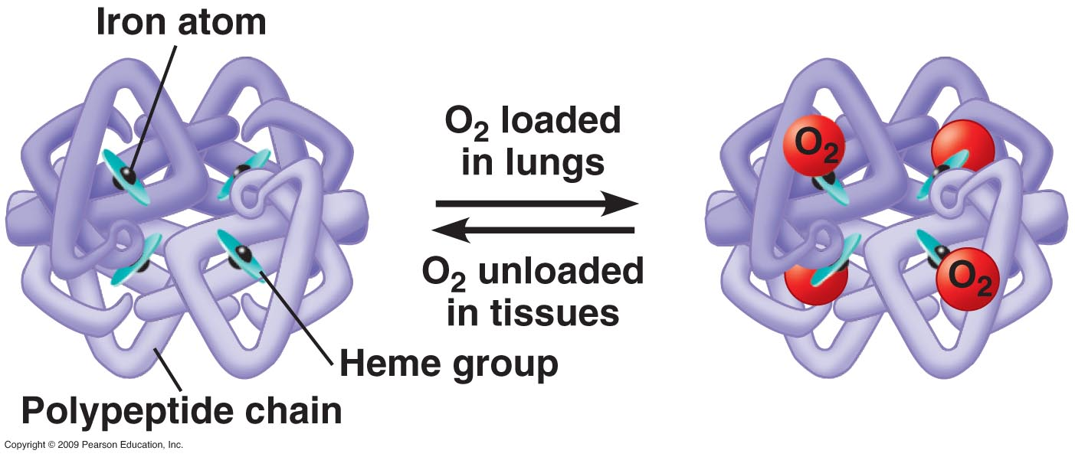
http://mycozynook.com/22_11HemoglobinO2-L.jpg

This change occurs because of a change in the amount of oxygen attached to the hemoglobin molecule. The oxygen people breath is carried by the hemoglobin in the bloodstream to various parts of the body. When oxygen leaves the hemoglobin, the change is detected by the MRI as a change in the strength of the emitted radio signal. Yet the change is very small, and would be difficult to detect in just a few scans. So a statistical analysis must be done by computers to identify these changes over time. The fMRI images are then color coded to identify increases or decreases in the levels of oxygen in the hemoglobin based upon these signals.

During a fMRI scan, a patient can be asked to perform a mental and or physical task while their brain is being scanned. The scan will then indicate the areas of brain where the oxygen levels are changing and thus indicates where brain activity is happening.

Oxygenated hemoglobin levels change all the time in the human brain. The fMRI collects data on changes across the whole area being scanned. To produce useful data, it is necessary for computation to compare the ‘normal’ brain data to the same brain while engaged in some particular activity. The difference in the rates of consumption are what appear in the fMRI image. The coloration is proportional to the amount of change in oxygen level.

A normal MRI scan produces an anatomical image showing tissue structure. The functional MRI additionally produces a functional layer that is typically overlaid on the anatomical image to create an image with colored areas highlighting the places where oxygen levels are changing. fMRI scans plot what is called a BOLD signal (Blood Oxygenation Level Dependent). These signals are averaged over three dimensional regions called voxels, like a two dimensional pixel with an added dimension.

The intensity of the magnetic field is inversely proportional to amount of detail shown in the fMRI image. In other words, in a scanner with a stronger magnet, the image produced will be able to show more fine detail. Typical fMRIs now operate with magnetic fields between one and a few Tesla. Very high resolution fMRIs use magnets up to about 10 Tesla and produce the smallest voxels to date and thus the highest resolution fMRI images.

One Tesla is a large magnetic field. By definition, a particle with 1 Coulomb of charge (that would be nearly 10¹⁹ or 10 billion billion electrons) moving at 1 meter per second through a magnetic field of 1 Tesla would experience 1 Newton of force. The field strength of the signals in the human brain are on the order of 10⁻¹² Tesla, or 1 picoTesla. The magnetic field of the Earth is about 0.000030 T at the equator, or 30 microTesla. A typical refrigerator magnet is about 0.005 T, or 5 mT. The lifting magnet in a scrap yard might be about 1 Tesla. Further magnetic field strength examples can be found here: http://en.wikipedia.org/wiki/Orders_of_magnitude_%28magnetic_field%29

Patients entering MRI scanners must remove any metal that can be attracted to the magnet. Without this precaution, serious consequences can occur. Metal containing iron will be quickly attracted into the MRI scanner and ripped away from the body. Here is a video of a metal gas cylinder interacting with an MRI scanner’s permanent magnet:
http://www.metacafe.com/watch/2194395/mri_scan_accident/
http://youtube/_pkRqbxDTcw

It is important to realize the changes observed in the fMRI are really changes in levels of oxygen in the brain. This is then presumed to connect to the ‘usage’ of the same regions of the brain. But the data itself is really just showing the changes in oxygen levels and not brain usage.

For an example of what a fMRI can do, consider a Stroop Test. This is a test designed to challenge your brain to manage both language cues and visual cues at the same time. In the first version, you will be asked to identify which written words match a written word presented to you. In the second, you’ll be comparing the color of words to the names of the colors. And in the third, it will be a combination of each. Then, take a look at fMRI images of people while participating in a Stroop Test!
Try this Stroop test here:
http://snre.umich.edu/eplab/demos/st0/stroopdesc.html

Here is a second version of a Stroop test written as a game. This test asks you to click on the balls on the screen where the written name of the color matches the color of the ball.
http://www.braintraining101.com/the-stroop-test/

One study used fMRI imaging to study brain activation during a Stroop test. Different individuals took the test while their brains were imaged. This set of images can be viewed here: https://pantherfile.uwm.edu/neuropsy/www/fmri.html

For a nice example of dynamic information acquired with fMRI, take a look at this article. Researchers at the Stanford School of Medicine have studied human brain activity while listening to classical music. In particular, the group identified that the brain area that focuses on attention is highly active during the pauses in classical music. Read this article and be sure to watch the included video showing an animated series of fMRI images of the brain. The fMRI images are made each second and displayed with the music the patient was listening to during the imaging.
http://med.stanford.edu/news_releases/2007/july/music.html

Understanding humans is a complex task. The use of many types of imaging helps people to have a visual glimpse of the human body in a variety of ways. Many of the presenters at the Nobel Conference use fMRI images to investigate human brain activity. Throughout the conference, you will be able to view fMRIs collected in the research of several of the presenters. Please explore the discussion questions to promote your own understanding of the usage of fMRI scans.

Discussion Questions

- In what way are radio signals used in an MRI scanner?

- What does the word resonance refer to in the term MRI?

- What advantages are there in using fMRI vs. MRI?

- What key molecule carries oxygen through the body? How is this molecule critical to the creation of an fMRI image?

- What is suggested at the maximum magnetic field exposure level for a cardiac pacemaker?

- A Stroop Test investigates human’s ability to identify both written words and colors. Which of these is typically more easily and quickly perceived by humans?

- Seek and describe several current uses of fMRI imaging.

- Describe at least three limitations of functional MRI images in understanding brain activity.

- Describe the key assumption that scientists make to connect fMRI results to brain activity.
Discussion Questions - Teacher’s Guide

- In what way are radio signals used in an MRI scanner?
They cause the protons to vibrate at different rates in different materials...thus causing the signals used to make the images.

- What does the word resonance refer to in the term MRI?
This refers to the vibration of atoms from their relaxed state to their magnetized stated and back again. Resonance refers to the large amplitude of vibration caused when the atoms natural rate of vibration is the same as the frequency of the radio wave driving the vibration.

- What advantages are there in using fMRI vs. MRI?
fMRI’s provide a view of changes in oxygen levels in body tissue. The advantage of fMRI is that it can indicate where oxygen changes are taking place, and presumably where the brain is most active.

- What key molecule carries oxygen through the body? How is this molecule critical to the creation of an fMRI image?
One hemoglobin can have up to four oxygen molecules attached to it. It is key to fMRIs as the imaged produced in the fMRI indicates changes in the level of oxygen in this molecule.

- What is suggested at the maximum magnetic field exposure level for a cardiac pacemaker?
It is about one milliTesla, or 10⁻³ T. See the chart at http://en.wikipedia.org/wiki/Orders_of_magnitude_%28magnetic_field%29

- A Stroop Test investigates human’s ability to identify both written words and colors. Which of these is typically more easily and quickly perceived by humans?
Humans tend to more quickly perceive written text than the color of text.

- Seek and describe several current uses of fMRI imaging.
See the Appendix for several samples.
Here is an interesting presentation: www.ncsconline.org/d_research/stl/StarkDecdeption_Gray_compress.pdf

- Describe at least three limitations of functional MRI images in understanding brain activity.
The first is the assumption that oxygen activity indicates brain activity and that a lack of oxygen changes indicates a lack of brain activity.
As these images are based upon changes, there isn’t likely much baseline data to use.
The reference brains used in the medical field are references of geographic location within the brain and not function.
The mathematical analysis only produces a probability of function over the length of the scan.
The size of the voxel may be larger than the actual area of the brain activity.

- Describe the key assumption that scientists make to connect fMRI results to brain activity.
The key is the assumption that oxygen activity indicates brain activity and that a lack of oxygen changes indicates a lack of brain activity.

Appendix

Several resources are available to further illustrate the principles of fMRI with the annotated links below.

This four minute talk illustrates some basic concepts of an fMRI from neuroscientist Christopher deCharms:
http://blog.ted.com/2008/03/25/christopher_dec/

Here is an extensive, readable, background in fMRI:
http://www.fmrib.ox.ac.uk/education/fmri/introduction-to-fmri/introduction

This is a USA Today article about how meditation can change brain activity as shown on an fMRI:
http://www.usatoday.com/news/health/2008-09-09-brain-scan-emotions_N.htm

This article discusses brain reactions with fMRI to an avatar vs. a human face:
http://evolution.anthro.univie.ac.at/institutes/urbanethology/projects/simulation/fmri/index.html

The Whole Brain Atlas, Harvard Med School
http://www.med.harvard.edu/AANLIB/home.html

Synesthesia appearing on fMRI
https://docs.google.com/a/isd77.k12.mn.us/viewer?a=v&q=cache:T1S9u2MXghMJ:www.psych.ndsu.nodak.edu/mccourt/Psy460/Primary%2520Source%2520Readings/Nunn%2520et%2520al%2520%28color-word%2520synesthesia%29.pdf+fMRI+and+synethesia&hl=en&gl=us&pid=bl&srcid=ADGEESgllLJpkTWDQHxxyGiQ2ySD2Khou_fGU9jysaMf1gCzh3hDTKv4imz72_j92FLxUqWS2Kz37qy6dbHRzKHUeOMz7jCdNUHWnYs_LbKTVRhrTchEvqTOkMt9bEymMO6a-6beVZvw&sig=AHIEtbRe_RGQAeGqG6_pTIBpSGIU0gH1vA

Hi-RES fMRI with response to visual stimulation
1.5 mm x 1.5 mm voxels.
http://en.citizendium.org/wiki/File:Fmri_visual.jpg

Phantom Limbs – efficiency of brain usage vs. training time
http://www.liv.ac.uk/researchintelligence/issue36/phantom.htm

Criticism on the uncertainty of fMRI images due to the computational nature of the images presented:
http://www.mutuallyoccluded.com/2008/12/vul_fmri_cognitive_neuroscience_social_interaction/

