Welcome to Gustavus!
Congratulations on your admission to Gustavus and welcome to our community. Gustavus is a four-year residential campus, which means a vast majority of students live on campus and experience life in a residence hall. One of the important decisions you will make is where you want to live! In order to assist us in helping you decide where you hope to live and what sort of roommate you are looking for next year, you must complete a Housing Contract and Preference Form.
To complete the necessary forms by the JUNE 1, 2015 DEADLINE, follow these simple instructions:
- Visit the Residential Life homepage (https://gustavus.edu/reslife/)
- Click on the “Housing” link on the left-hand sidebar. You’ll see a link to “Incoming/New Student Housing.” Click that to enter the first-year housing portal. Read through the information carefully and begin the “Online Form” linked at the bottom.
- You will be able to log in as a guest. If you know your Gustavus username and password already, use that – it will auto-populate some information for you. Fill in your information and your preferences.
- Click “submit” and you’re done!
You will also see our Residential Life Handbook linked to the page with the online form. That PDF provides very important information about our housing contract and about Residential Life and college policies. Please review that document before completing your housing contract and preference forms.
Our housing assignment process is outlined on the “Incoming/New Student Housing” page. We intend to notify incoming students of their housing by August 1, 2015.
The housing contract and preference form must be submitted by JUNE 1, 2015 in order to have preferences considered. We cannot guarantee your top housing choice, but we can assure you that living on campus can be a great experience no matter which building you live in! If you have questions about the form, please contact the Residential Life office at 507-933-7529.
Again, welcome to Gustavus. The Residential Life office is excited and proud to provide a home away from home for you during your time at Gustavus.
Sincerely,
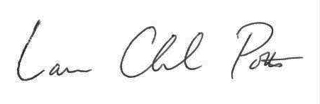

Charlie Potts - Director of Residential Life
cpotts@gustavus.edu

Follow us on Twitter (@Gustie_ResLife) and like us on Facebook (“Gustavus Residential Life”) for updates throughout the spring and summer!

