Student Application: [Insert BusinessOrganization Name Here]
Student Name(s) Here

Executive Summary
Executive summary here – 100 words (Times New Roman – 12)
This is your elevator pitch. This should be a very brief description of your company/ business idea and will be published as your business description in the 2024 Gustie Entrepreneur Cup program / published materials if selected to compete. Please delete all gray text in this document and use black text for your input.
- Name
- Business Name
- Compelling/catchy story or tagline (brief)
- What you sell/do – in a few sentences

Opportunity
Opportunity statement here – 500 words

What problem are you solving? What is your solution? What makes your product innovative and unique? Who is your target market, and how large is the addressable market? Note: Impact Ventures - be sure to emphasize the impact of your idea and how you will measure it. Use paragraph formatting, with bullet points to emphasize lists or multiple ideas, breaking the text up a bit.
- Describe your product/service, the problem it solves, your value proposition, and what is unique or innovative about your approach.
- Is this a breakthrough idea and an innovative approach? What makes it different than what is out there already? Is it due to branding, accessibility, distribution model, and design elements? How do you know it is a breakthrough idea?
- Who is your target customer and how large is your addressable market? Use demographic information such as age range, income level, location, hobbies/interests, etc. The librarians can help you find this information if you can narrow in on who you are targeting. Consider presenting this information in a phased approach – for example, “Initially, we will market to x and x within a 60-mile radius of Rochester, MN, which is x number of people or businesses. In year 2, we will expand to the Twin Cities, yielding x customers.”
- How profitable is this business idea? Make sure to talk through your thought process on presenting the numbers, outline assumptions, and discuss profitability based on testing and market size.

Plan
Plan Overview here – 500 words

What activities will you perform and who are your partners/vendors? How will you make money (sources of revenue, unit economics for profit margins, etc.)? How will you reach your customers (channels) and create awareness of your product? What resources (capital and other) will be required? Include a list of key team members/advisors.
- Is this a commercially viable idea and why? Aside from how innovative it is, how do you know the market will adopt this idea?
- Explain your business model including operating, sales, and marketing plans. How will you build awareness and convert potential customers into sales?
- What activities will your company perform and what partners/vendors will you rely on?
- How will your product/service be priced and positioned?
- Through what channels will you reach your customers?
- How will you create awareness and convert customers?
- Include a list of key team members/advisors that are helping you develop the business.
- Include summary financial projections and assumptions including projected volume, unit pricing and margins, major operating costs, and capital needs.
- Discuss risks and challenges.

Progress
Progress statement here – 500 words

Do you have a prototype, customers, strategic partners, or revenue? Tell us what milestones you've achieved to validate the opportunity and bring your product/service to market. How can you demonstrate that customers truly want your product/ service, and are willing to pay for it? (500 words)
- What progress have you made? Discuss test results, prototypes, MVP if you have them.
- Do you have any customers or pilot customers? How much revenue have you already generated? What other sources of funding have you secured?
- What milestones have you achieved to validate the opportunity and bring your product/service to market?

Appendix: [Business/Organization Name Here]
Student Name(s) Here

Executive Summary
**Note: This additional section is optional and is simply a spot to include additional details about portions of your plan. These topics are commonly asked about in more detail by investors, bankers, and business partners. Keep, remove, or add sections and make it your own. At a minimum, a Profit and Loss (Income) Statement is highly recommended. By detailing some of the plan areas below, you may find it easier to summarize your application sections above. You may choose to include bits of these details on your slides in the verbal pitch (list of products/services with prices) or high-level P&L statement. Be prepared to answer judges’ questions with the details below. The maximum Appendix length you should submit is 5-6 pages.
Product/Service Details
Product or service details text, photos, lists, etc.
This may include:
- Listing of products and services with [retail] prices – include additional charges (set-up fees and personalization pricing for example)
- Detailed Pricing Model – includes above with additional detail: discounts for bulk orders, wholesale pricing, donation structure if aligned with non-profit giving strategy, etc.)
- Photos of your products/prototype
- Mock-up website (build in PPT or design program and include screenshots of what the website would look and feel like)
Market Analysis
Product or service details text, photos, lists, etc.
- This may include:
- Detailed description of who you are targeting and why
  - Demographic information
  - Interest/hobbies / associations that may help you reach your target market
- More detailed list of market size (population or number of organizations based on demographic information above)
  - Total population of xxx {Rochester + Mankato + Albert Lea + Owatonna for example]
  - % of the population who fit the demographic model outlined above
  - Summary of market #’s
- Projected market share – what percentage of that market can you realistically penetrate in Year 1? Year 2, 3, 5?
Sales & Marketing Strategy/Plan
Product or service details text, photos, lists, etc.
- This Website and sales platform – What URL is available for your branded name?
- Social media channels and handles
- Other forms of marketing
- Details about how you plan to create messaging and turn it to sales
- What are some messaging ideas? Monthly partnerships, weekly stories/features, 3x/week product posts
Financial Projections
Assumptions, goals, and projections here
Often referred to as Pro-Forma Statements when projecting financials, your plan should include at least a Profit & Loss Statement (also known as an Income Statement) to predict (in the planning phases) or report on how profitable your business will be based on assumptions. You may also want to develop a Cash Flow statement and a Balance Sheet (to show how much you have in assets, and how much you own in liabilities). All of these are available as Excel Templates so you can choose the format that best appeals to you. Keep them simple but think through how you are getting to the numbers you are inputting into the statements. You may want to create statements for years 1 – 3 on each report so we can see growth.
Tips and Resources:
- Investopedia has a great article that explains the three financial statements and key terms used in each to guide you through your Pro-Forma creation.
- Excel > New > More Templates > Search for Profit & Loss (or Cash Flow, Balance Sheet)
*The benefit of using these templates in Excel, is that many of them have other tabs that will help you come up with the numbers found on the report. For example, enter Sales Revenue by month > Income
- Once you have created your statements in Excel, screenshot the statement and include it in the Appendix.

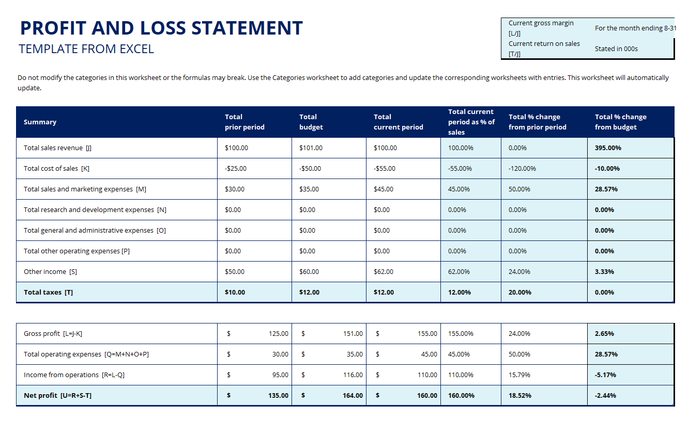
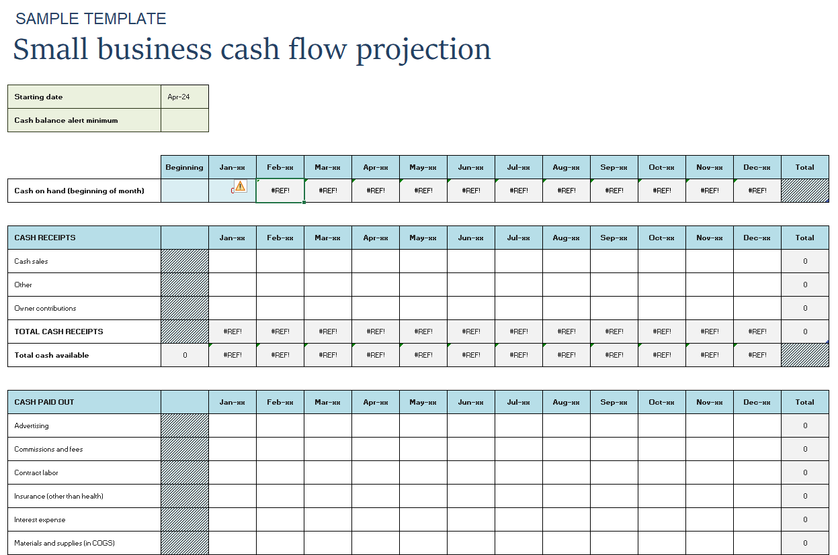
General Tips
As you review your overall business idea and draft application, keep these things in mind to create a compelling pitch:
- Your pitch should tell a story. The idea should be presented simply and should be easy to understand in the first 15-30 seconds. You want the judges to believe in you as an entrepreneur! Watch a few episodes of The Shark Tank to get ideas on the story-telling approach and level of detail.
- Focus on the innovative idea and the team who can make it happen. Why should they invest in you? Share the skillsets and experience you bring to the table to bring this idea to market.
- If you share challenges in your journey, the idea is more credible because any investor will poke holes in the plan to evaluate gaps and risks. Beat them to it! Share a high-level of some of your challenges and be prepared to answer questions in more detail.
- Tie the business idea to Gustavus’ Core Values for bonus points!

Additional Resources

- Video on creating a Value Proposition
- Minnesota Cup Resources and Application
- Watch the Shark Tank for creative Pitch ideas (Verbal Pitch should be 8 minutes and an additional 2 minutes for questions from judges + 2 minutes from the audience)

