Connecting to Dr. Steven Chu: Speaker at the 50th Nobel Conference
Biography and History - A Project with Connections!

Document Overview:
This is an activity designed to help a class build a background in the life’s work of Dr. Steven Chu. It is built as a jigsaw-style activity with a series of time periods to be explored and shared with emphasis on the connections between each of these phases of Dr. Chu’s life and work.

Minnesota Academic Science Standards:
9.1.2.1.1 Understand that engineering designs and products are often continually checked and critiqued for alternatives, risks, costs and benefits, so that subsequent designs are refined and improved.
9.1.3.2.2 Analyze possible careers in science and engineering in terms of education requirements, working practices and reward

National Science Education Standards:
Science in Personal and Social Perspectives
Content Standard F: Science and technology in local, national, and global challenges

Next Generation Science Standards
HS-ETS1-1 | Analyze a major global challenge to specify qualitative and quantitative criteria and constraints for solutions that account for societal needs and wants.

Objectives:
I can develop an understanding of and share with another person a description of the path Dr. Steven Chu’s scientific work has followed.
I can recognize the connections that propelled him from each phase of his work to the next.

Type of Activity:
Small group research and presentation followed by large group sharing and discussion.
Duration:
Two class periods:
Day 1 - Conduct research and develop an understanding of a particular time period
Day 2 - Present the timeline by group while students build a mapping of the connections.

Connection to Nobel speakers:
Dr. Steven Chu has become a very public representative of the scientific community in recent years. His broad background in experimental science and experience with science policy gives him a unique perspective from which to share and connect scientists and policy makers. He presents at the 50th Nobel Conference in October of 2014 entitled “Where Does Science Go From Here?”

Concepts & Keywords:
Energy, Timeline, Change over time, Networking, Stanford, Bell Labs, Curiosity, Science in Personal and Social Perspectives, Dr. Steven Chu
Description of Activity:
Small Group Jigsaw Activity: Students research a specific time frame within Chu’s lifetime, career, and interactions/influences that propelled him into the next phase of his career. Students then share their group’s focus with the whole class and the class develops a broad picture/web of Chu’s life.
Materials:
Research tools for each group - internet access.
Presentation tools for each group - either internet based or paper based...for sharing a small groups research with the whole class.
Activity:
This is set up as a jigsaw activity for small groups of students. Dr. Chu’s work is split into seven time periods in the table below. Each small student group is to develop a sharable piece (poster, webpage, Prezi, presentation, Fakebook page) on one particular time period. The group is also to identify the connections that brought Dr. Chu into the next phase of his work by considering the question: “What people/circumstances caused him to relocate or find new directions in his research and location?”
After developing these presentations, each group is to share their findings to the rest of the class. Individual students are to create a diagrammatic representation of chronological time periods, and the connections between each period.
Teacher Notes:
The intent of this activity is to guide students to learn both about the life experiences of Dr. Chu and the significance of other people in his work. His biography includes several descriptions of short conversations--turned to professional connections--turned to new career directions. The goal of asking students to highlight these people and connections is to help them realize the significance of networks and curiosity throughout the lifetime of one’s education and professional career. Dr. Chu provides a great example of both a “Growth Mindset”, “Grit”, and an ability to be a lifelong learner. We encourage you to start by showing students the 8 minute video clip of Dr. Chu on “The Daily Show” (linked from the relevant resources section of this document). It gives a quick view of his background and his commitment to energy fluency in a light environment.
Many themes may arise in the student discussion throughout this activity. The goal is help students understand the breadth of scientific work of Dr. Chu and the threads that connect the phases of his work. Scientific knowledge is tentative and influenced by a community of people. This activity may bring up several themes, among which could be: connections in science, the value of networking, curiosity, his focus as an experimentalist - constantly exploring ways to make things better, the changing nature of science, science in personal and social perspectives, stick-to-it-ness or persistence.
Connecting/influential people helped propel Dr. Chu throughout his scientific career. Chu’s career was not a single static accomplishment and many of his significant discoveries or career moves were heavily influenced by the people he was worked with.
Each small group could share the results of their research on poster board around the classroom in a jigsaw-style activity. Alternately, groups could be charged to develop a presentation of their information using the social media tools relevant to the time period they are working with. The summary timeline includes suggested social media types that fit each time span. We encourage you to choose the approach that best fits your students and classroom setting. We have provided a two-page handout for students with basic directions for both the small group research as well as the individual student summary of the work.
For students needing accommodations, you may want to provide the "A Basic Timeline of Dr. Chu" handout for support.

A Timeline of Dr. Chu’s Work
Suggested Small Group Media Type | Time Span | Dr. Chu’s Location | Highlights
Letter/postcard to parents? | 1970-1978 | Grad: Berkeley  PostDoc: Berkeley  Asst. Prof: Berkeley | Realized a passion for experimental science.  Investigated/Published research on the weak neutral force between electrons and quarks.  Offered Professorship at Berkeley.
Photo Album with captions.  Usenet Bulletin Board Posts  textfiles.com/ | 1978-1987 | Bell Labs | Realized passion for experimentation outweighed his theoretical work. Encouraged to “invent a new field”. Investigated optical fluorescence to quantum electrodynamic corrections in an atom.
AOL page | 1987-2004 | Stanford | 1997 Nobel Prize  - Laser cooling and trapping of atoms.  - http://www.nobelprize.org/nobel_prizes/physics/laureates/1997/press.html
Facebook | 2004-2009 | Director of LBL | An outspoken advocate for scientific solutions to the twin problems of global warming and the need for carbon-neutral renewable sources of energy.
Twitter | 2009-2013 | Secretary of Energy | Founded and funded ARPA-E for high risk, high reward scientific research (i.e. Sun Shot Challenge).  Doubled installation of solar photovoltaic cells in 2011 exceeding 1.8 gigawatts of energy.  Funded and formed 46 Energy Frontier Research Center’s (ERC’s) in 2009.
Instagram | 2013-Present | The Chu Lab, Stanford | Developing tools for biophysical and biomedical applications (super-resolution microscopy).  Developing imaging techniques able to analyze neurons at the molecular level.  Investigating chemical, structural, and genetic components of biofilms
Media Type Reference: http://www2.uncp.edu/home/acurtis/NewMedia/SocialMedia/SocialMediaHistory.html

A Basic Timeline of Dr. Chu - adapted from the Nobel Prize Biography of Dr. Chu
1948 - Born to a well-educated family, as the middle child of three boys. Born into a family where advanced degrees were prominent.
As a child Chu enjoyed taking things apart, putting things back together, and building things. When he wanted to learn to pole vault, he built himself a pole.
Talented teachers guided him through AP Physics and AP Calc. Chu found a role model in HS Physics teacher, Thomas Miner. Miner and other teachers prompted Chu to ask questions, investigate, and ultimately led Chu toward a career of science and experimentation.
Undergraduate Education:
Chu went to the University of Rochester in New York for physics, then to CalTech to continue his work. A summer program brought him to the National Radio Observatory where he explored red shift in radio astronomy. This piqued his interest and fit his experimental style.
Graduate Education:
1970 - Berkeley
Chu enjoyed experimenting with music. Listening to the out-of-tune notes play by a violinist perpetuated him to study the frequency shifts in music. This work helped him develop a better understanding of his own passion to be an experimentalist.
1974 - PostDoc at Berkeley
First published work on weak nuclear interactions.
1978 - Asst. Professor position at Berkeley
Needed to break out and experience other universities or opportunities and be exposed to different people and ideas.
1978 - Joined Bell Labs as an experimentalist. Chu loved the atmosphere of play and curious freedom as an experimentalist; he never returned to Berkeley.
Chu worked with with several experiments there - in atomic physics and energy transfer.
Published most accurate, as of “to date”, measurements of quantum electrodynamic effects on an atomic system. Chu’s work provided experimental evidence of Richard Feynmann’s ideas.
1983 - Head of Quantum Electronics Research Department at Bell Labs (moved to Bell in NJ)
Conversations with others there led him to work on Laser Trapping and Cooling experiments….mid 1980s.
1987 - Left Bell Labs for Stanford. In California, he engaged in teaching, researching, and further developing laser cooling techniques together with his students.
Meanwhile, Chu explored polymer physics and biology, developing techniques to manipulate DNA by attaching polystyrene molecules to it to move it around. A friend connected him to molecular biology which led to developing imaging of DNA molecules in motion. This work pushed the knowledge of polymer dynamics.
1997 - Nobel Prize in Physics for “Laser Trapping and Cooling of Atoms”. Chu presented his Nobel Lecture entitled “The Manipulation of Neutral Particles” for development of methods to cool and trap atoms with laser light.
From: "Steven Chu - Biographical". Nobelprize.org. Nobel Media AB 2013. Web. 18 Jun 2014. <http://www.nobelprize.org/nobel_prizes/physics/laureates/1997/chu-bio.html>
2004 - Chu took a leave of absence from Stanford to return to UC Berkeley as the director of Lawrence Berkeley Laboratories.
There he focused the laboratory’s work on Solar Energy and Clean Energy Resources.
Chu began the Helios project which investigates how to create a non-biological photosynthetic process to drive the formation of a high energy-density fuel from carbon dioxide and water. http://www2.lbl.gov/LBL-Programs/helios-serc/html/overview.html
2008 - Chu became an Emeritus Professor at Stanford
2009 - Chu was appointed as the US Energy Secretary by President Obama.
As the Energy Secretary, Chu founded and funded the Advanced Research Projects Agency - Energy (ARPA-E) for high risk, high reward scientific research (i.e. Sun Shot Challenge).
Highlights of Chu’s work as Energy Secretary:
- Microorganism Photosynthesis programs with the Helios project. http://arpa-e.energy.gov/?q=arpa-e-embedded-video/electrofuels-more-efficient-photosynthesis
- Doubled installation of solar photovoltaic cells in 2011 exceeding 1.8 gigawatts of energy.
- Funded and formed 46 Energy Frontier Research Center’s (ERC’s) in 2009.
- Engaged United States in the Clean Energy Ministerial meetings.
2013 - Dr. Chu heads back to Stanford, and now runs “The Chu Lab” in Dept of Physics and Dept of Molecular and Cellular Physiology

Extensions and Follow-up Activities:
While at Berkeley, Dr. Chu developed an initiative to study the efficiency of different types of roofing materials on climate. Design an experiment that will test the impact of black vs. white roofing on energy use within a building. Use your data to present an argument either in favor of or opposed to local governments requiring buildings to have roofs of a certain color.
Article Discussing Economic Impacts of Black, White, or Green (Vegetated) Roofs: http://newscenter.lbl.gov/2014/01/21/white-green-or-black-roofs-berkeley-lab-report-compares-economic-payoffs/
Additional “Cool Roof” and Heat Island Information and Impacts from the EPA: http://www.epa.gov/heatislands/resources/pdf/CoolRoofsCompendium.pdf
Additional research conducted at LBL about energy and roofing:
http://heatisland.lbl.gov/coolscience/cool-science-cool-roofs
http://newscenter.lbl.gov/2010/07/19/cool-roofs-offset-carbon-dioxide-emissions/
http://newscenter.lbl.gov/2011/07/26/efficacy-of-cool-roofs-varies-from-city-to-city/
Write a grant proposal for your school - to place a solar array on the school building to reduce the annual cost of electrical energy by 50%.
New MN grants to startup solar farms:
http://www.xcelenergy.com/Environment/Renewable_Energy/Renewable_Energy_Grants

Write an abstract for an ARPA-E proposal. http://arpa-e.energy.gov/?q=arpa-e-site-page/about
- roofing
- solar roadways on cars, solar on homes, solar mandate on all new public buildings, solar mandate on all parking structures / buildings with x minimum cubic feet.
- magnet on spring through coil on backpack (old mit project?)
- kids with magnets running thru metal hallways in schools?
- piezoelectric roadways or house / building floors.
- weather balloons, magnet in a coil in a box on a truck, river/ocean/lake beach ball w/ em generator as energy source
- Peltier effect on engine surface or house walls to generate electrical energy.

Visual for Average American Energy Usage
http://visualeconomics.creditloan.com/how-the-average-american-uses-energy/

EPA Website on Climate Change
http://www.epa.gov/climatechange/

Relevant Resources for students:
Letter from Dr. Chu upon resignation as the US Secretary of Energy
http://energy.gov/articles/letter-secretary-steven-chu-energy-department-employees
AutoBiography upon receipt of the Nobel Prize in 1997
http://www.nobelprize.org/nobel_prizes/physics/laureates/1997/chu-bio.html
Optical Tweezers Described, Stanford Report, July 16, 1997
http://news.stanford.edu/news/1997/july16/polymers.html
“On Returning to Stanford”, Stanford Report, May 15, 2013
http://news.stanford.edu/news/2013/may/steven-chu-qanda-051513.html
“Obama Picks Berkeley Lab Director Steve Chu for Energy Secretary”, Berkeley Lab Website
http://www2.lbl.gov/Publications/Director/index-Chu.html
ARPA-E Website: http://arpa-e.energy.gov/
Annenberg Video on Laser Cooling and Trapping of Atoms
http://www.learner.org/courses/physics/unit/text.html?unit=5&secNum=7
Dr. Chu’s appearance on “The Daily Show”
http://thedailyshow.cc.com/videos/7y64wv/steven-chu
Dr. Chu’s talk “The World’s Energy Problem and What We Can Do About It” at the 43rd Nobel Conference, “Heating Up: The Energy Debate”.
http://www.youtube.com/watch?v=leSqXeNwKSU&index=2&list=PLHuAoPzfQhGFENjV83NrenI6m6a-VByNH

Dr. Steven Chu - Subgroup Research Directions
1. Within your small group, research Dr. Chu’s career and life during the specific time period you were assigned and identify 3 to 5 of his most significant career highlights within that time.
2. Research and identify 2 to 3 influential people in Dr. Chu’s life during that time period and explain what impact these people had on Dr. Chu and how their influences helped propel Chu into the next phase of his career. Pay particular attention to which people helped him to explore new topics that appear later in his life’s work.
Using your research and the presentation method specified by your teacher, create an organized presentation of the information you’ve gathered. This should last about 5 minutes and include an overview of Dr. Chu’s work during the time period. For each influential person, be sure to provide and share clear evidence of the link(s) or influences that led Dr. Chu to move from his current work to the next phase of his life.
Group’s Assigned Time Period:_________________________________________
Where was Dr. Chu?  Significant career highlights in this period | People of influence, connections to Chu

Dr. Steven Chu - Individual Summary Directions
While learning about Dr. Chu’s work from each group in the class, develop a visual representation of Dr. Chu’s path through his work. Try to capture both the key phases of his life and work as well as the people that he made connections with. For each influential person, try and answer the question, “How did Dr. Chu’s interactions with this person impact his future career path?”
Below are two samples of what these representations could look like. Develop a representation that captures the connections shared by your classmates.
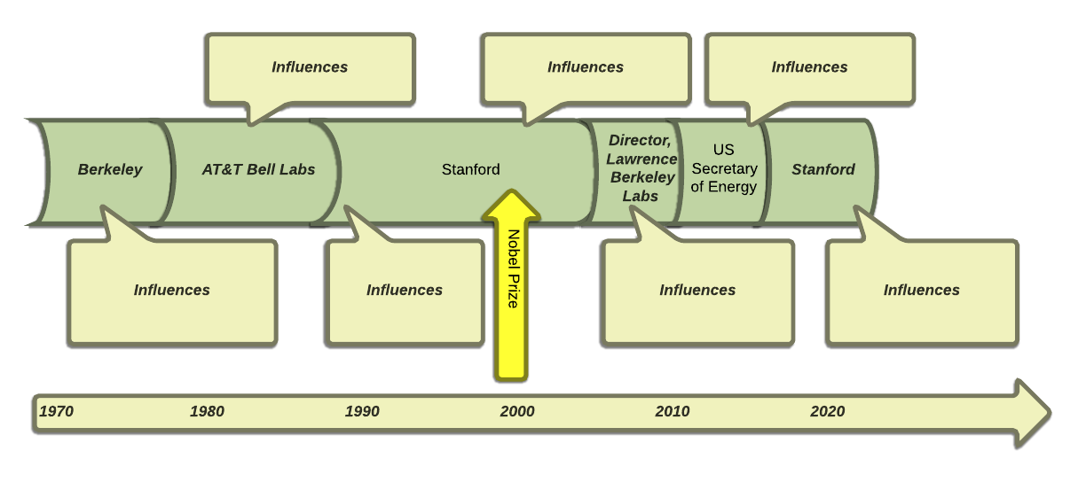

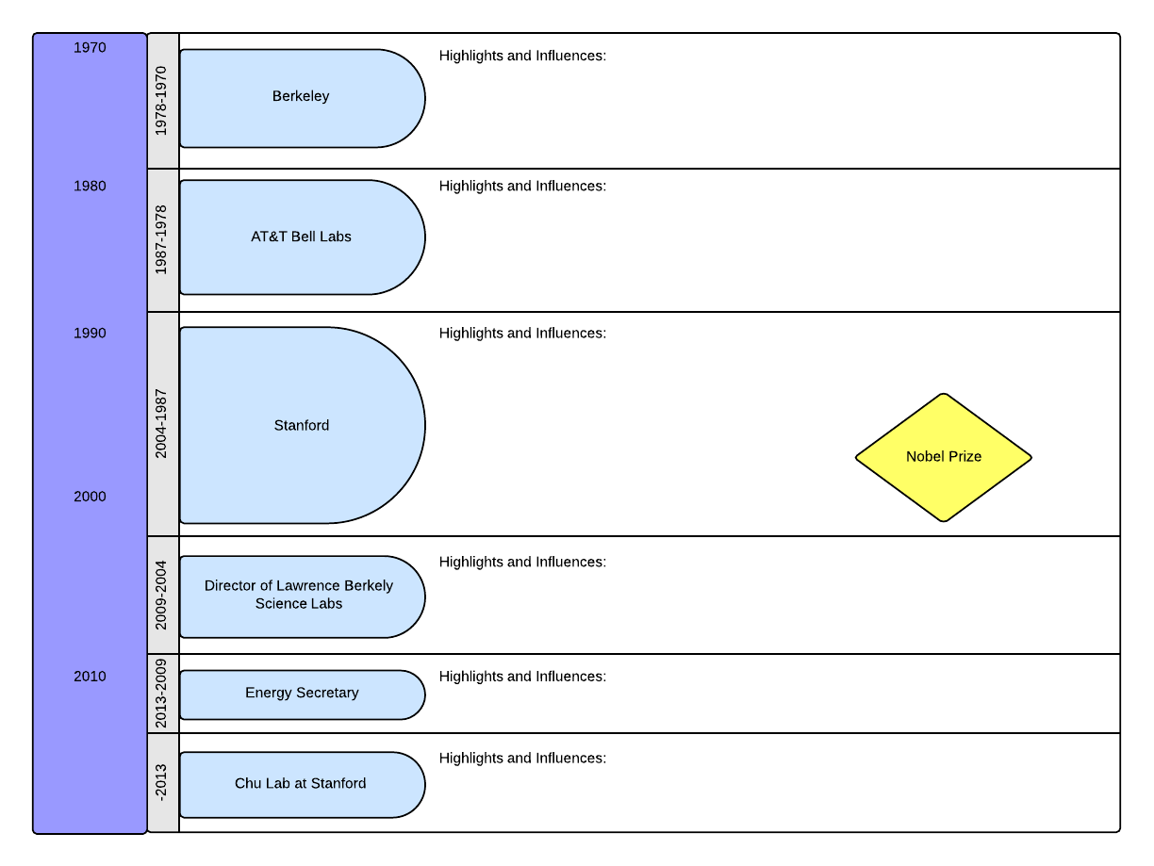

http://www.nap.edu/openbook.php?record_id=4962&page=193
http://www.nap.edu/openbook.php?record_id=4962&page=193
http://mindsetonline.com/whatisit/about/
https://sites.sas.upenn.edu/duckworth/pages/research
http://www.nobelprize.org/nobel_prizes/physics/laureates/1997/chu-bio.html

